

**Mission 12:**

**Night Light**

**Student Workbook**



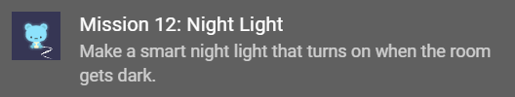

**Ready to light up the night?**

Make a smart night light that turns on when the room gets dark.

Go to the Mission 12 Log and fill out the   
Pre-Mission preparation.

* CodeX has a built-in light sensor. What projects can it be used for?

**Mission 12: Night Light**



You'll use the CodeX's built-in light sensor to detect light and use the pixels as a night light!

You will create two versions of the   
night light.

**Project Goals:**

* + Use a simple on/off control
    - Light (pixels) turn on when the sensor detects “dark”
  + Variable dimming
    - Brighter light for a darker room

**Mission 12: Get started**

* Go to <https://make.firialabs.com/> and log in.



* Go to Mission 12



* Click and start Mission 12.

**Objective #1: Let there be sensor**

So you want to make a night light?

* This is going to be easy with CodeX
* It has its own built-in light sensor
* Click on and read the first 2 paragraphs
* Go to the Mission Log and answer the questions.
* Then close the toolbox.



**Objective #1: Let there be sensor**

**DO THIS:**

* Close the instruction panel
* Use the camera controls to rotate and zoom in
* Click on the light sensor
* Create a new file named **NightLight**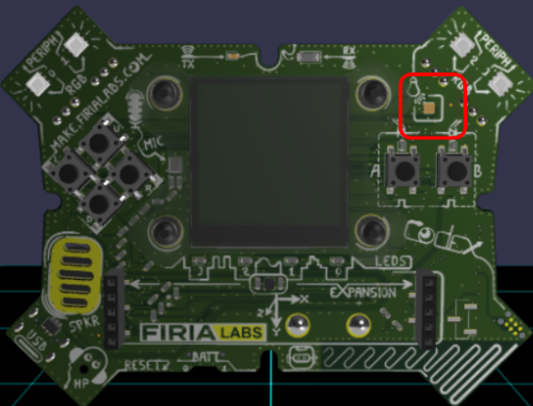

**Objective #2: Light sensing code**

The light sensor changes, or converts, light level into a digital value.

* **Dark** = lower values
* **Light** = higher values
* Digital values go from 0 to 65,535
* Any value below 2,000 is pretty dark!
* To read from the light sensor, use:
  + **value = light.read()**

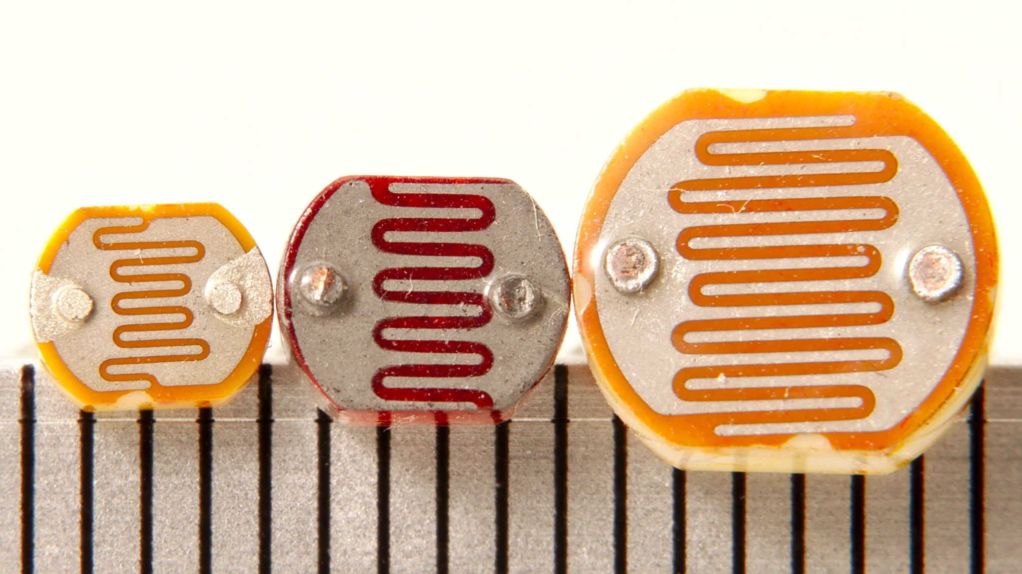

**Objective #2: Light sensing code**

This mission will use CodeX’s built-in light sensor.

* Go to the Mission Log and complete the table as you work on this code.

**DO THIS:**

* Import codex and time modules
* Read the light sensor
* Display the value
* Change the light on the sensor by trying three different types of light:
  + Regular room light
  + Shine a flashlight for bright light
  + Cover the sensor with your hand for dark light
* 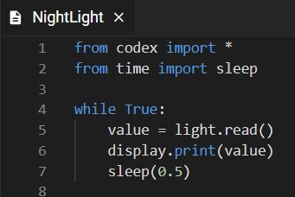Write the value readings in the Mission Log

**Objective #3: Pixel filler**

* Stadiums turn on all their lights when it gets dark.
* You will turn on the four LED pixels when CodeX senses it is dark.
* You can set all four LED pixels the same color quickly with this code:

pixels.fill(WHITE) -- turn on   
pixels.fill(BLACK) -- turn off



**Objective #3: Pixel filler**

**DO THIS:**

* Add an if statement to your code
* If the value from the sensor is dark   
  (less than 2000) turn on the pixels
* Else, turn off the pixels
* Delete display.print() and sleep()
* Test the code by covering and uncovering the sensor

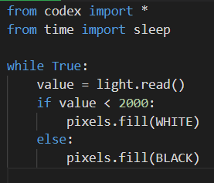

**Objective #4: Dimmable light sensor**

Your night light is either fully on or completely off.

* If it is a little dark, a little light will do.
* Make the night light gradually brighter as the room gets darker.
* Add information to the pixels.fill()   
  command to control the brightness   
  of the pixels.
* brightness is a value from 0 to 100
* Use the brightness level like this:

**pixels.fill(WHITE, brightness = 20)**



**Objective #4: Dimmable light sensor**

**DO THIS:**

* Look at your table from Objective #2
* What value did you write down for room light?
* Use a number a little less than that for your ROOM value.
* For example, if my table looked like this:

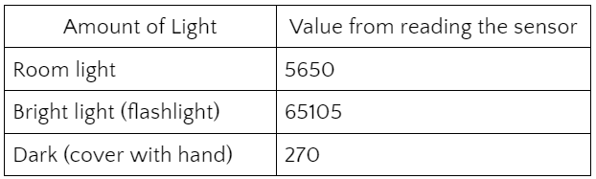

* I could use **ROOM = 5500**

**Objective #4: Dimmable light sensor**

**DO THIS:**

* Define ROOM
* Change the condition of the   
  if statement
* Do a little math to calculate the brightness level
* Test your code
  + *WARNING - it may be a little glitchy*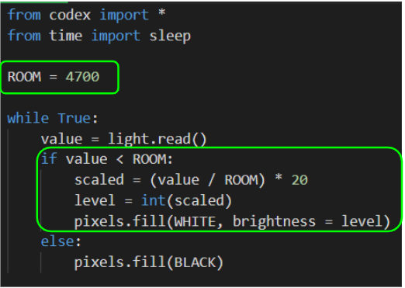



**Mission Quiz: Light Test**

Test your skills by **taking the quiz**.

**Objective #5: Reversed**

When testing your code, you might notice that the pixels get darker as the room gets darker.

* You want the opposite!
* You will need to reverse the math.



**DO THIS:**

* Change the math to reverse the value for brightness
* 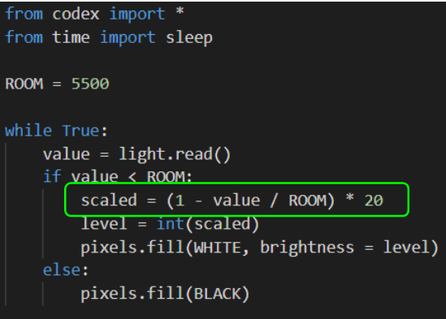Test your code

**Mission Complete**

You have completed the twelfth mission. 

**Do this:**

* Read your “Completed Mission” message
* Complete your Mission 12 Log
  + Post-Mission Reflection

**Wait! Before you go … Clear the CodeX**

Go to FILE -- BROWSE FILES

Select the “**Clear**” file and open it

Run the program to clear the CodeX

**Okay. Now you can go.**